Aerodynamic Analysis and Fuselage Integration
To achieve low-speed flight and better lift efficiency, the aircraft’s wingspan was selected similarly to the Cessna 172 model, but with some minor modifications. The wing planform was designed with a slightly aggressive taper angle.
In order to maximize airflow and reduce the drag coefficient, the aircraft’s taper ratio was determined as 0.65 and the taper angle as 11 degrees. Although these values are considered relatively aggressive for a small-scale UAV, they remain within acceptable limits.
XFLR5 was used for the wing analyses, and the required values and graphs were obtained accordingly.
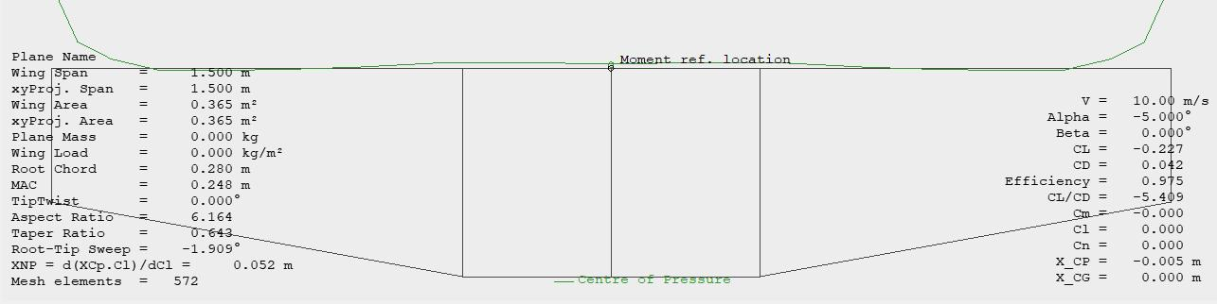
According to the analysis results, the first obtained value was a wing efficiency factor of 0.975, which is considered quite high for a UAV. However, since XFLR5 generally produces optimistic results and possible imperfections during real flight conditions must be taken into account, evaluating this efficiency value as 0.95 would be more realistic. Even at this value, the efficiency remains considerably high.
The taper ratio was calculated as 0.643, which is consistent with the previously specified design parameters. The wing’s aspect ratio was determined to be 6.164. The aircraft’s flight speed was assumed to be approximately 10 m/s, and with a wing area of about 0.365 m², the stall speed was predicted to be 7.4 m/s.

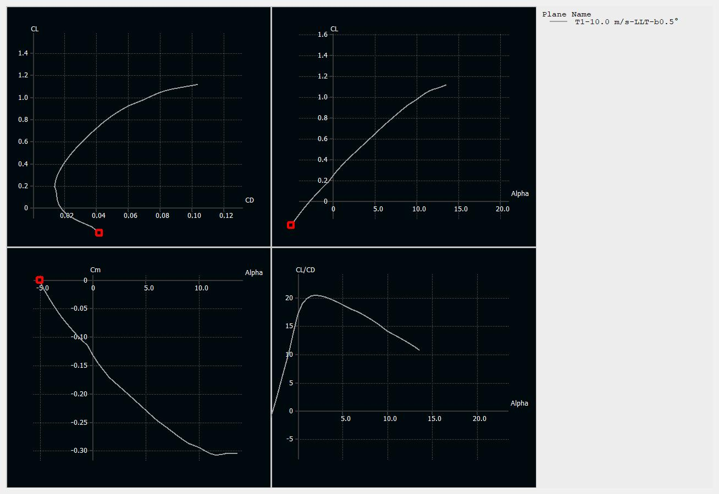

This set of graphs demonstrates the aerodynamic performance of the wing profile and provides a comprehensive evaluation of its behavior during flight.
The graph in the upper left represents the lift–drag polar (CL–CD). This graph shows how much lift force is produced for a given amount of drag. The smooth shape of the curve indicates that the airfoil behaves predictably. At low drag values (approximately 0.01–0.02), lift increases efficiently. However, when higher lift is demanded, drag increases more rapidly; this is a normal behavior, but it also indicates that efficiency decreases under high-lift conditions.
The graph in the upper right shows the variation of the lift coefficient with angle of attack (CL–α). This is one of the most important graphs. Lift increases almost linearly up to approximately 10–11 degrees, which represents the normal operating region. Beyond this point, the curve begins to flatten, indicating that the airfoil is approaching stall conditions (flow separation). The maximum lift coefficient is around 1.85–1.9, showing that the airfoil is stable but not specifically designed for extremely high lift generation.
The graph in the lower left illustrates the variation of the moment coefficient with angle of attack (Cm–α). The negative nature of the curve and its tendency to become more negative as the angle increases indicate that the airfoil naturally produces a nose-down pitching moment. This behavior is advantageous for stability because it helps prevent uncontrolled nose-up motion. However, in order to maintain equilibrium, the tail surfaces must generate additional force, which may slightly increase the total drag.
The graph in the lower right shows the lift-to-drag ratio (CL/CD–α), which represents aerodynamic efficiency. This graph indicates the most efficient operating point of the airfoil.
It is used to determine the most efficient operating condition of the airfoil. The maximum value is approximately 20 at an angle of attack of around 3–4 degrees. This represents the most efficient flight condition, where the highest lift is achieved with the least amount of drag. Beyond this point, drag increases more rapidly than lift, causing the aerodynamic efficiency to decrease.
Overall, this wing profile demonstrates stable, predictable, and efficient performance within the medium operating range. Therefore, it is suitable for controlled UAV flights. However, since it is not designed to generate extremely high lift, it is not ideal for very low-speed operations or heavy payload missions. The optimum operating range is approximately between 3–5 degrees angle of attack. Since stall begins around 11–12 degrees, the aircraft should be designed so that normal flight conditions remain well below this limit.

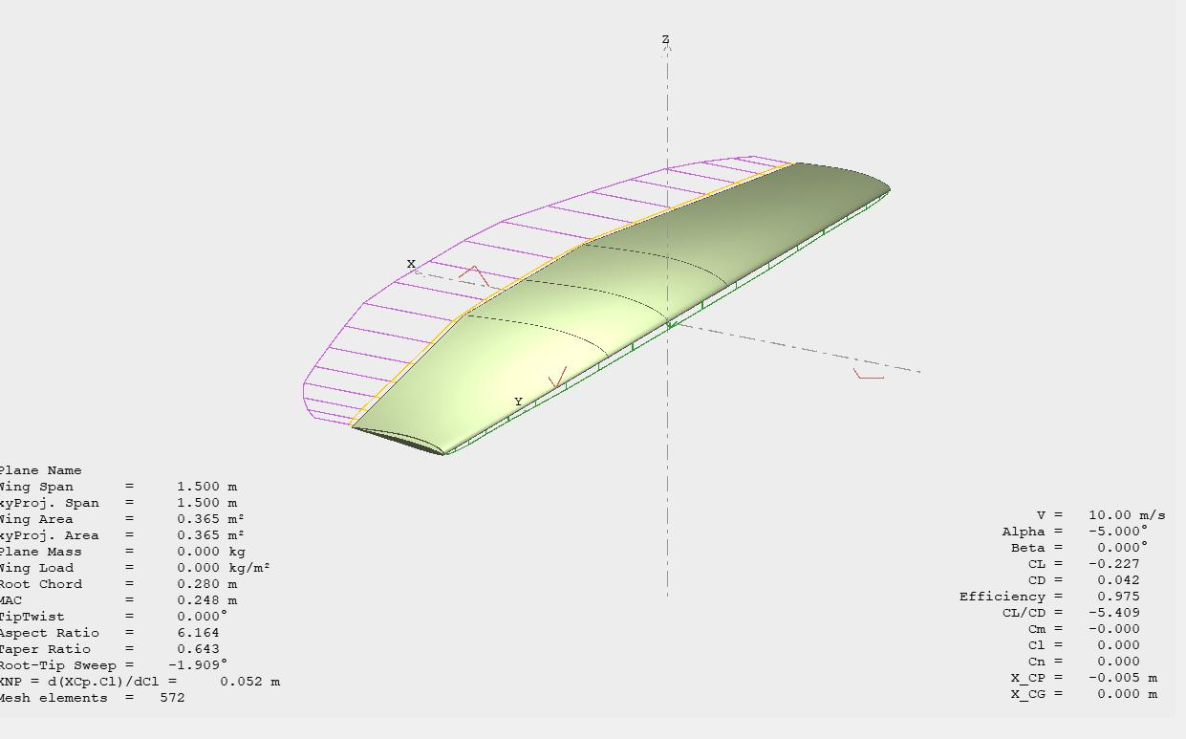
This figure shows the aerodynamic analysis of the entire wing performed using Lifting Line Theory (LLT) at a flight speed of 10 m/s and an angle of attack of −5°. The wing has a span of 1.5 m, an area of approximately 0.365 m², and an aspect ratio of about 6.16, which are considered quite reasonable values for a UAV.
Under these operating conditions, the wing produces a negative lift coefficient (CL ≈ −0.227), meaning that it generates a downward force instead of lift. This is an expected result because the angle of attack is negative. The drag coefficient (CD ≈ 0.042) is relatively high for such a low-lift condition. As a result, this leads to a negative aerodynamic efficiency value (CL/CD ≈ −5.4), meaning that the wing operates inefficiently under these conditions and causes energy loss.
The wing visualization illustrates the lift distribution along the span. The color distribution and panel arrangement indicate that the lift is distributed relatively smoothly, even if it is not perfectly elliptical. This is a positive characteristic because it suggests the absence of local stall (flow separation) or sudden aerodynamic irregularities. However, since the angle of attack is negative, the entire wing is operating in an unfavorable aerodynamic regime.

The pitching moment coefficient (Cm ≈ 0) is very close to a neutral value. This indicates that, under these specific conditions, the wing alone does not significantly pitch the aircraft either upward or downward. The center of pressure (X_CP ≈ −0.005 m) is also very close to the reference point, showing that the aerodynamic forces act at the expected location.
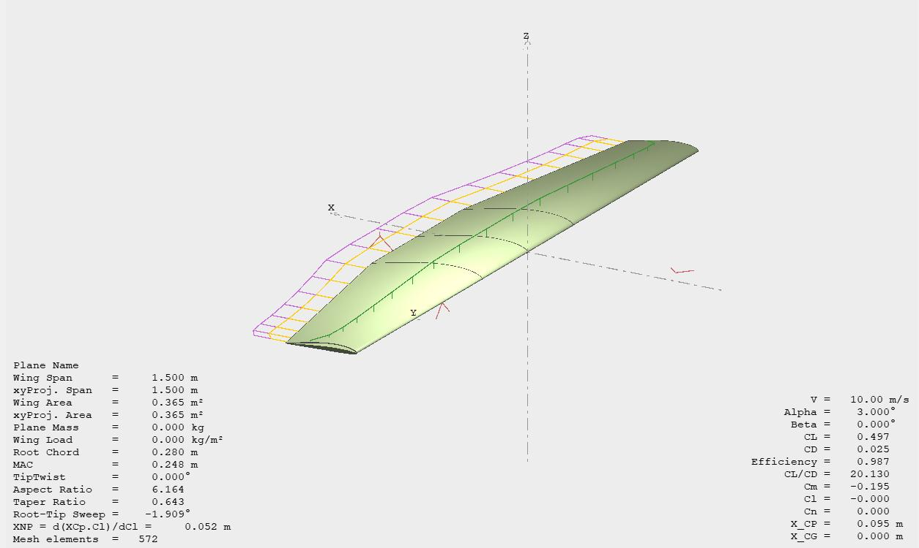
This figure shows the aerodynamic analysis of the designed wing using Lifting Line Theory at a free-stream velocity of 10 m/s and an angle of attack of 3° (typical cruise conditions). Under these conditions, the wing produces a lift coefficient of approximately CL ≈ 0.497, indicating that sufficient lift is generated for stable and balanced flight. The drag coefficient is relatively low (CD ≈ 0.025), resulting in high aerodynamic efficiency (CL/CD ≈ 20.1). This value is consistent with the previously obtained airfoil data and demonstrates that the three-dimensional wing configuration preserves the favorable efficiency characteristics of the airfoil.
The lift distribution along the span is smooth and continuous, without noticeable irregularities or local peak points. This indicates a balanced aerodynamic load distribution across the wing and reduces the risk of early local stall formation or excessive loading near the wingtips. Such a distribution is highly desirable both in terms of aerodynamic efficiency and predictable flight characteristics.
The pitching moment coefficient is negative (Cm ≈ −0.195), indicating a nose-down pitching tendency. This characteristic is generally associated with aerodynamic stability because it creates a restoring moment when the angle of attack increases. The magnitude of the moment is moderate, meaning that the horizontal tail will need to generate balancing force, but without causing excessive trim drag.
The center of pressure is located approximately at X_CP ≈ 0.095 m, indicating that the aerodynamic forces act slightly behind the leading edge relative to the reference point. This position is typical for conventional wing designs and supports longitudinal stability when properly balanced with the aircraft’s center of gravity.
Overall, the results demonstrate that the wing exhibits high efficiency, stable pitching moment behavior, and an appropriate lift distribution under cruise conditions. These characteristics indicate that the current wing geometry is suitable for sustainable flight and does not exhibit any significant aerodynamic weaknesses within the examined operating range.

